INTERNATIONAL PODCAST DAY
Sennheiser’s new MOMENTUM Wireless headphones are your perfect podcast companion

Sydney/Wedemark, September 27, 2019 – Podcasts are taking over the media landscape – in the US, the number of people having listened to a podcast in the last month has steadily increased over the last decade, leading to 32% in 2019 – reason enough to celebrate International Podcast Day on September 30th. Just grab your smartphone, download a podcast app - and don’t forget to put on the right headphones if you don't want to annoy those around you. Whether you’re on the train, on your way to university, running in the park, or relaxing at home after work – put on the new MOMENTUM Wireless headphones from Sennheiser and off you go. We are introducing five podcasts you should not miss out on below.

Wherever you go, the new MOMENTUM Wireless headphones are the perfect podcast companion | 

1 –Sh**ged Married Annoyed
The weekly podcast from Rosie and Chris Ramsey gives you intimate insights into the relationship of the Ramsey family, while also answering questions from the public. Whether it's a dispute in the relationship or parenting, nothing is left out. If you're not afraid of very private subjects, this could be the right podcast for you.

2 – My Favorite Murder with Karen Kilgariff and Georgia Hardstark
“Stay sexy and don't get murdered” – since 2016, this has been the catchphrase of the two comedians Karen Kilgariff and Georgia Hardstark. Every week, they publish an episode of their famous true crime podcast together. The style of the podcast is lighthearted and very entertaining: In dialogue, they recount and discuss a true crime story each episode. Both funny and scary, it’s a podcast for anyone looking for a different take on crime stories.

3 – Call Her Daddy
If you're embarrassed about a story from your youth, you better listen to this podcast – you’ll probably feel better afterwards! Relationships, sex, the NY social scene and as many embarrassing stories as you can handle add to the mix in this great podcast from Alexandra Cooper and her best friend Sofia Franklyn. No blushes are spared in this entertaining treasure trove of stories from the wild twentysomething lives of these two podcasting girlfriends.

4 - Ladies, We Need To Talk
As the title suggests this is a podcast for women, tackling topics that are considered delicate or taboo and not often talked about. An Australian podcast from the ABC, each episode highlights a different topic about issues relating to Australian women that generally wouldn’t come up in everyday conversation. Join host Yumi Stynes as she tears open the sealed section on life.

5 – 3ShotsOfTequila
Just think about the sort of open and honest conversations that you can only really have with a best friend – where literally nothing gets left out. Marvin Abbey, Mr Exposed and Tazer Black do this in public. Their close friendship lets them serve up straightforward talk that can go deeper than your usual podcast: not least because of the generous 90-minute running time of each episode. There’s nothing average about the 3ShotsOfTequila podcast.

The perfect podcast companion: Sennheiser's new MOMENTUM Wireless
Podcasts are perfect entertainment on the go. The new MOMENTUM Wireless headphones from Sennheiser enhance your favourite podcast with superior sound, while their remarkable craftsmanship and incredibly comfortable design ensure they are a treat to wear even for long listening sessions. Auto On/Off and Smart Pause features ensure you never miss a word: The new MOMENTUM Wireless headphones start up instantly when unfolded. When you take the headphones off, playback pauses and seamlessly resumes when you put the headphones back on. Three Active Noise Cancellation modes block out the outside world and let you fully immerse yourself in your favorite podcast. Alternatively, the Transparent Hearing function lets you enjoy your podcast and still be aware of your surroundings, if need be. Sennheiser’s new MOMENTUM Wireless is available as of now for $599.95 AU (MSRP). Find out everything you need you know at www.sennheiser.com/momentumwireless

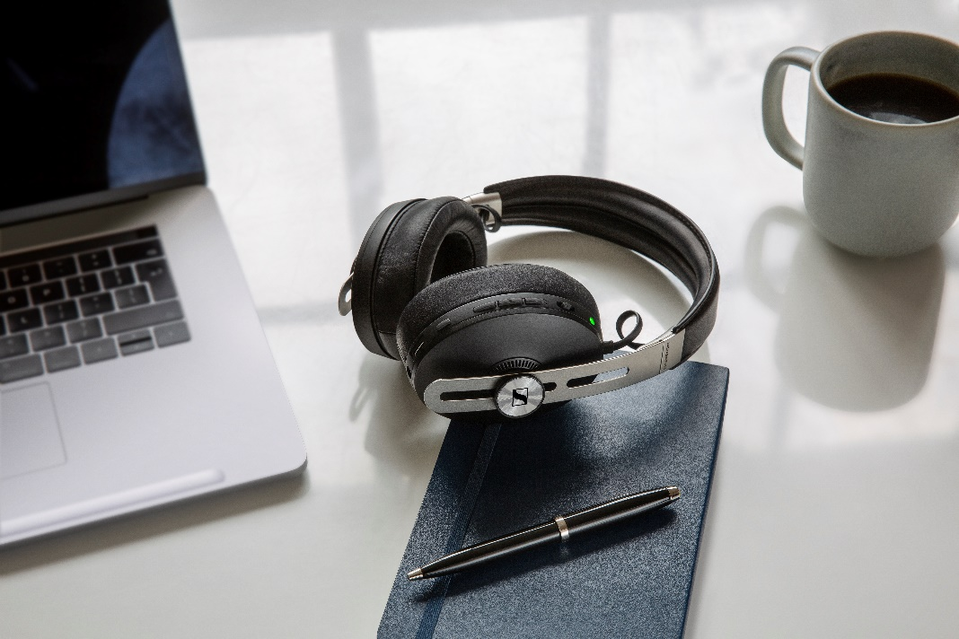 | Superior sound, various smart features, Active Noise Cancellation and Transparent Hearing – the MOMENTUM Wireless enhances your podcast experience

Start your own podcast with Sennheiser
Feel inspired to start your own podcast? Sennheiser has teamed up with music producer, sound engineer and professional podcaster Marc Mozart to help podcast beginners get started: The tutorial series "How to Podcast" offers a free podcast guide to kick things off – from concept creation to tips on the right recording software and the best microphone to marketing your very own podcast. The video series and all further information are available here: www.sennheiser.com/how-to-podcast

About Sennheiser
Shaping the future of audio and creating unique sound experiences for customers – this aim unites Sennheiser employees and partners worldwide. Founded in 1945, Sennheiser is one of the world’s leading manufacturers of headphones, loudspeakers, microphones and wireless transmission systems. Since 2013, Sennheiser has been managed by Daniel Sennheiser and Dr. Andreas Sennheiser, the third generation of the family to run the company. In 2018, the Sennheiser Group generated turnover totaling €710.7 million. www.sennheiser.com

Global press contact Local Press Contact
Sennheiser electronic GmbH & Co. KG Sennheiser Australia & New Zealand
Jacqueline Gusmag Heather Reid
Communications Manager Consumer Communications Manager
T +49 (0)5130 600-1540 T +61 (0) 448 119 609
jacqueline.gusmag@sennheiser.com heather.reid@sennheiser.com

Website (thepodcasthost.com). (March 12, 2019). Share of U.S. population that have listened to an audio podcast in the last month from 2008 to 2019 [Graph]. In Statista. Retrieved September 19, 2019, from https://www.statista.com/statistics/270365/audio-podcast-consumption-in-the-us/

